1. **Problem Definition**

1. Title of the project: Regression Analysis to Predict Mileage
2. Problem Definition: Create a project on Regression Analysis. Build a Regression model to Predict Mileage.
3. Aim & Objectives:

The aims and objectives of a mileage prediction regression analysis can vary depending on the specific context and goals of the analysis. Here are some possible aims and objectives:

1. To develop a regression model that accurately predicts the mileage of a vehicle based on relevant factors such as age, make and model, fuel type, driving conditions, and maintenance history.

2. To identify the most important factors that influence vehicle mileage and quantify their relative impact.

3. To assess the accuracy of the regression model by comparing its predictions to actual mileage data from a sample of vehicles.

4. To use the regression model to predict future mileage for individual vehicles or for a fleet of vehicles, and to provide recommendations for maintenance and replacement schedules based on these predictions.

6. To identify opportunities to improve fuel efficiency and reduce emissions by analyzing the relationship between mileage and factors such as driving style, route selection, and vehicle maintenance.

7. To develop customized regression models for different types of vehicles or different operating conditions (e.g. city driving vs. highway driving) to improve the accuracy of predictions and recommendations.

Overall, the aims and objectives of a mileage prediction regression analysis should be designed to meet the specific needs and goals of the business or organization conducting the analysis.

1. **Motivation**

Mileage prediction regression analysis can be an important tool for many industries, including automotive, transportation, and logistics. It involves using data on various factors, such as vehicle age, make and model, fuel type, driving conditions, and maintenance history, to predict how many miles a vehicle is likely to travel before requiring service or replacement.

One of the main reasons to perform mileage prediction regression analysis is to help businesses better plan and manage their vehicle fleets. By predicting when vehicles are likely to need maintenance or replacement, companies can reduce downtime, optimize maintenance schedules, and avoid unexpected breakdowns.

Additionally, accurate mileage prediction can help businesses make informed decisions about purchasing or leasing vehicles, as well as negotiating contracts with suppliers or customers. It can also be useful for consumers who want to estimate the value and lifespan of their vehicles.

Overall, motivation for mileage prediction regression analysis stems from the potential benefits it can provide in terms of improved efficiency, reduced costs, and better decision-making.

1. **Methodological Details**
2. Requirement Analysis :

A. Python with Libraries:

1.Numpy

2.Pandas

3.Seaborn

B. Jupyter Notebook or any text editor

C. Required dataset

1. Software requirements: Python 3, Jupyter Notebook
2. Hardware requirements: Windows with Python and any text editor installed.
3. Algorithm / Flow Chart:

The algorithm for mileage prediction regression analysis involves the following steps:

1. Data collection: Collect data on the relevant factors that influence vehicle mileage, such as vehicle age, make and model, fuel type, driving conditions, maintenance history, driver behavior, and route selection.

2. Data cleaning and preparation: Clean and prepare the data by removing any missing or inconsistent data points, and standardizing the data formats and units.

3. Variable selection: Choose the independent variables that will be used to predict the dependent variable (vehicle mileage). This step may involve using domain knowledge or statistical techniques such as correlation analysis.

4. Model development: Develop a regression model that predicts vehicle mileage based on the selected independent variables. This may involve using techniques such as simple linear regression or multiple linear regression.

5. Model evaluation: Evaluate the accuracy and validity of the regression model by comparing its predictions to actual mileage data. This step may involve using statistical techniques such as R-squared, mean squared error, and cross-validation.

6. Model refinement: Refine the regression model by adjusting the model parameters or selecting different independent variables to improve its accuracy and predictive power.

7. Deployment: Deploy the regression model in a practical setting by using it to make predictions about vehicle mileage and incorporating it into decision-making processes.

Overall, the algorithm for mileage prediction regression analysis involves collecting and cleaning data, selecting independent variables, developing and refining a regression model, and evaluating and deploying the model. By following these steps, organizations can gain valuable insights into their vehicle operations and make data-driven decisions that can help them reduce costs and improve efficiency.

1. **Results**

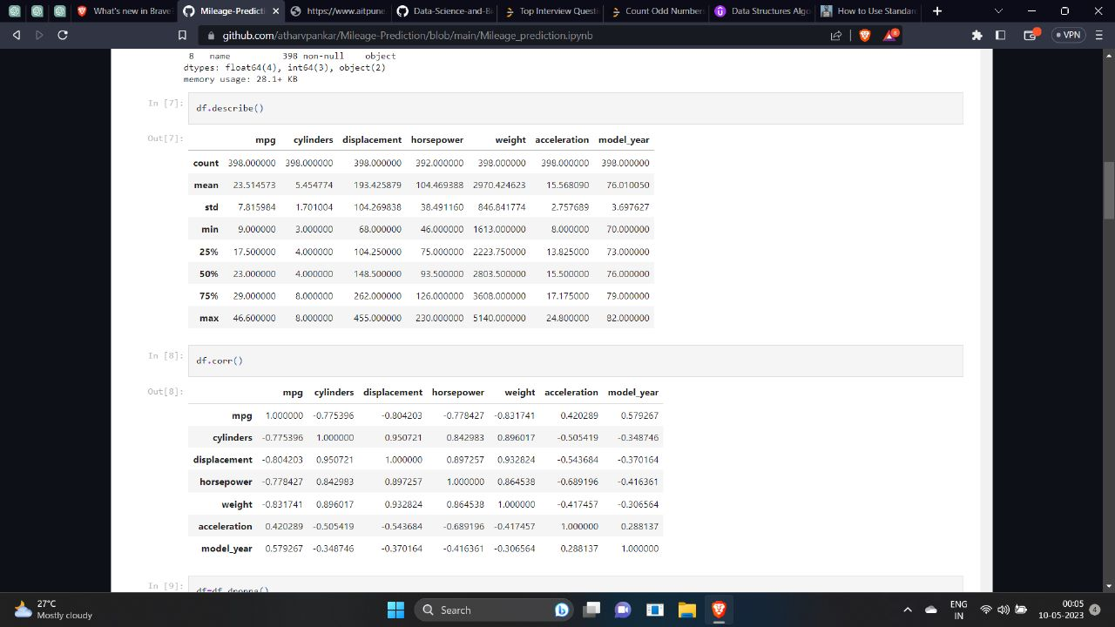

FIG 1

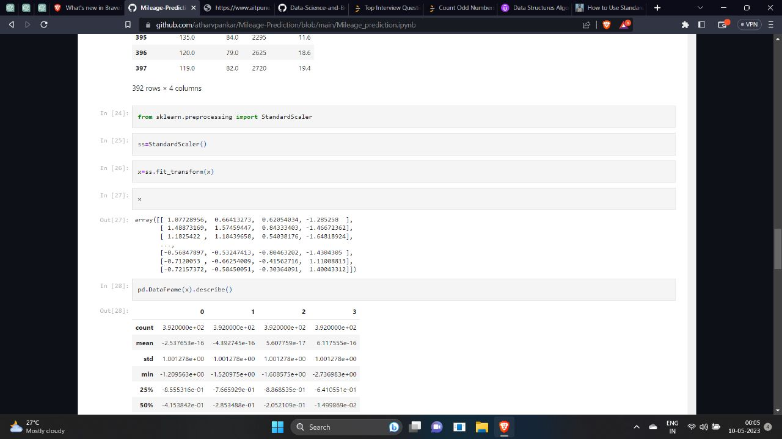

FIG 2

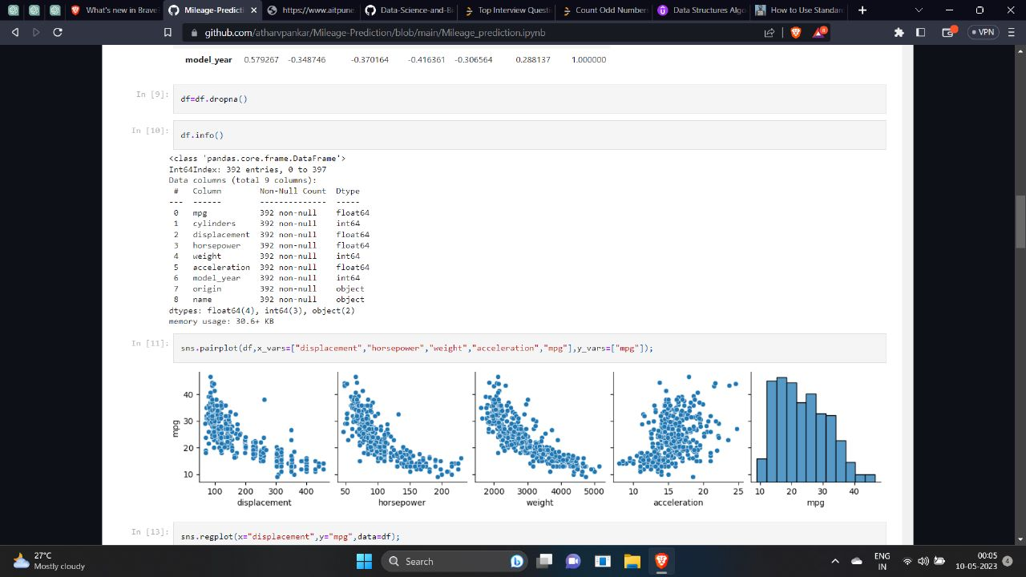

FIG 3

1. **Conclusion**

An internship/Course in data science has helped me become prepared to function in any of the respective professions with ease. Joining and then completing an internship in Data Science has helped me in a lot of ways along with my path to become a Data Scientist, a data analyst, or a data engineer. Internships serve as proof of your accomplishments and your foundational abilities, and I certainly found myself reaching these goals.

In conclusion, mileage prediction regression analysis can be a valuable tool for businesses and organizations that manage vehicle fleets. By using regression analysis to predict how many miles a vehicle is likely to travel before requiring service or replacement, companies can reduce downtime, optimize maintenance schedules, and avoid unexpected breakdowns.

Mileage prediction regression analysis can also help businesses make informed decisions about purchasing or leasing vehicles, negotiating contracts with suppliers or customers, and evaluating the cost-effectiveness of different maintenance and replacement strategies. It can even be useful for consumers who want to estimate the value and lifespan of their vehicles.

To achieve the aims and objectives of a mileage prediction regression analysis, it is important to carefully select the relevant factors that influence vehicle mileage and to develop a customized regression model that accurately predicts mileage for the specific context and goals of the analysis. It is also important to evaluate the accuracy of the model by comparing its predictions to actual mileage data and to continually update the model as new data becomes available.

Overall, mileage prediction regression analysis can help businesses and organizations optimize their vehicle operations, reduce costs, and make more informed decisions.